Use-Case Realization Report (Design)
Delete Survey

Issue <1.0>
Revision History
Date | Issue | Description | Author
<20/Oct/09> | <1.0> | <Initial version> | <Thomas Yap>

Table of Contents
1. Brief Description 4
2. Flow of Events 4
2.1 Standard Flow 4
2.1.1 Delete Survey 4
3. Interaction Diagrams 5
3.1 Collaboration Diagram for Delete Survey 5
3.2 Sequence Diagram for Delete Survey 6
4. Participating Objects 8
5. Class Diagrams 8
5.1 Class Diagram for Delete Survey 8
6. Derived Requirements 8

Use-Case Realization Report
Delete Survey

Brief Description
This use case enables the controller to delete survey from Survey Pool. It involves displaying the menu and form for selecting from the list to delete the record.

Flow of Events
The standard flow of events for this use case and any exceptions are described in the following subsections. The events are described in terms of Actors and Design Objects.

Standard Flow
This use case covers the Survey Maintenance - Delete Survey. The standard flows of these events are described below.

Delete Survey
The running of the application is shown in section 3.1. The flow of event is as follow:

- When the application start, the first operation to be performed is the startup operation of the main controller. This operation will create all the control objects and the entity objects necessary for operation Delete Survey:
  - The control object created is: SurveyBL Controller
  - The entity objects create are: survey_master, survey_qn_master and survey_qn_option

- The main controller will start the main function menu:
  - To start Delete Survey, operation page_load() is activated by SurveyBL Controller to display a Survey form.
  - PopulateSurveyList() will retrieve a title list of Survey for Portal Admin to select to be displayed on form Survey.
  - Upon confirmation by clicking delete button, the record will then be deleted from table using operation deletesurvey(), deletequestion() and deletequestionoption() to entity object survey_master, survey_qn_master and survey_qn_option.
  - The request can be cancelled by clicking cancel button and no data will be altered.
  - A confirmation message will be displayed by form Survey interface.

- Step 2 will be repeated until all deletions are completion. Then controller will terminate the application by issuing operation close.

Interaction Diagrams

Collaboration Diagram for Delete Survey
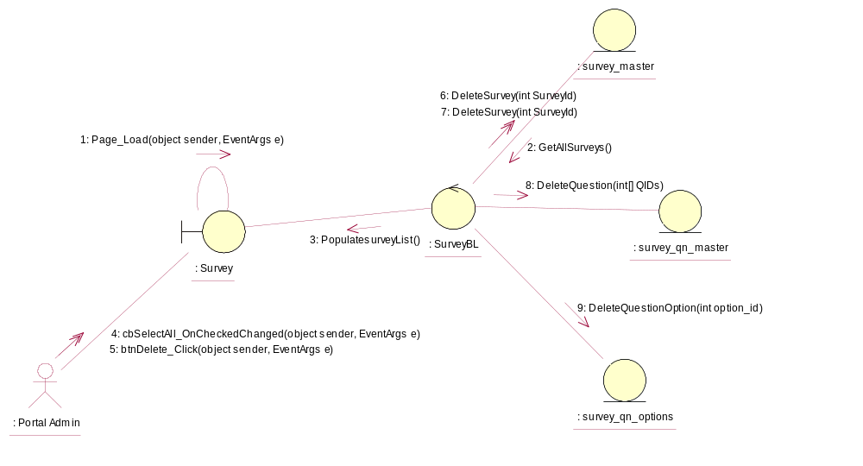

Sequence Diagram for Delete Survey
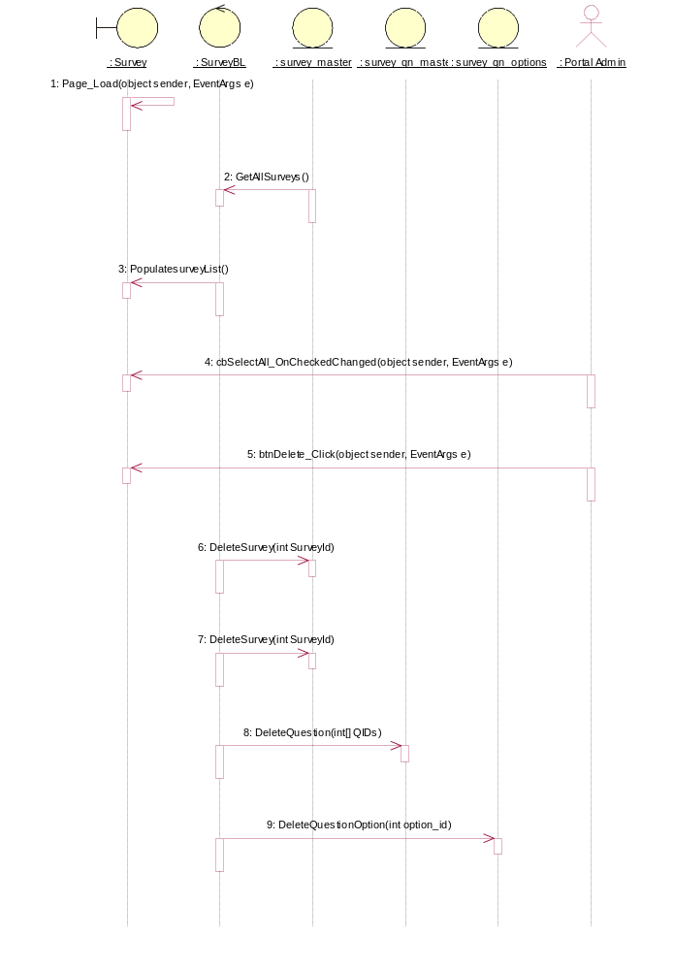

Participating Objects
: Portal Admin

: Survey

: survey_master

: survey_qn_master

: survey_qn_options

: SurveyBL

Class Diagrams

Class Diagram for Delete Survey
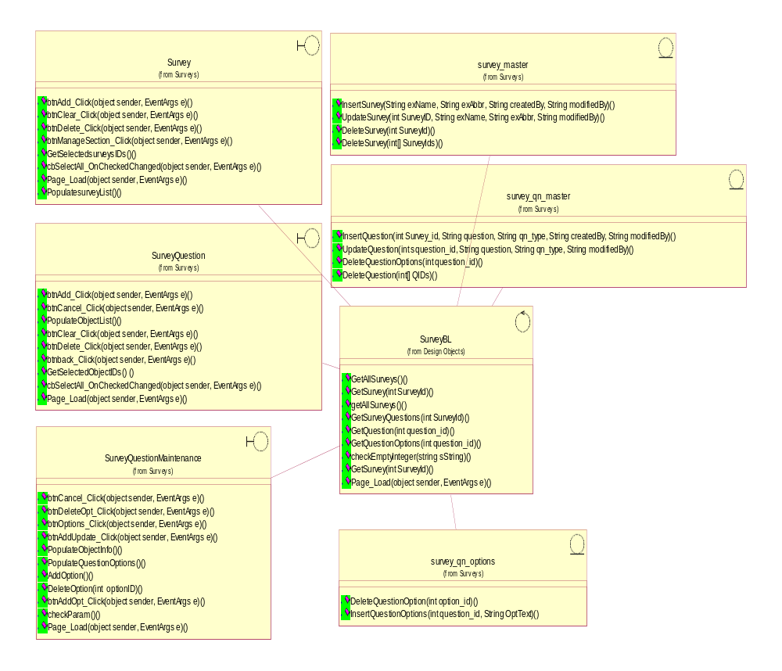

Derived Requirements
[enter the derived requirements here]

